Packet

📦 What Is a Packet in Networking?
# Source: Chatgpt (GPT‑5 Mini) at [12/14/2025]
A packet is the basic unit of data that is transmitted over a digital network. When you send any kind of data (like a webpage, video, or message), it's broken down into smaller chunks — called packets — to be transmitted efficiently and reassembled at the destination.

📦 Belongs to:
# Source: Chatgpt (GPT‑5 Mini) at [12/14/2025]
✅ Network Data Structures
(Alongside frames, segments, and datagrams)

🧠 Definition:
# Source: Chatgpt (GPT‑5 Mini) at [12/14/2025]
A packet is a structured piece of data that includes not only the payload (the actual content) but also headers that tell the network how to handle the data.

🧱 Structure of a Packet
# Source: Chatgpt (GPT‑5 Mini) at [12/14/2025]
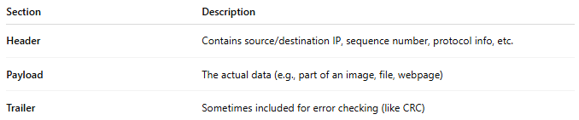
Section | Description
Header | Contains source/destination IP, sequence number, protocol info, etc.
Payload | The actual data (e.g., part of an image, file, webpage)
Trailer | Sometimes included for error checking (like CRC)
📌 Example: A 5MB file might be split into 5,000+ packets for transmission.

Here's a simple and clear breakdown of the 🧱 structure of a network packet, using a common example: a TCP/IP packet sent over an Ethernet network.

🧱 Example: Ethernet + IP + TCP Packet Structure
# Source: Chatgpt (GPT‑5 Mini) at [12/14/2025]
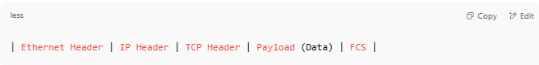
| Ethernet Header | IP Header | TCP Header | Payload (Data) | FCS |

Each part plays a specific role in delivering the data:

🔹 1. Ethernet Header (Layer 2 - Data Link)
# Source: Chatgpt (GPT‑5 Mini) at [12/14/2025]
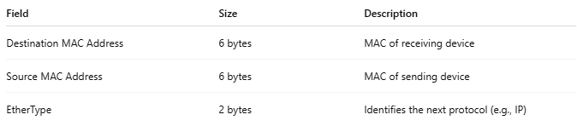

Field | Size | Description
Destination MAC Address | 6 bytes | MAC of receiving device
Source MAC Address | 6 bytes | MAC of sending device
EtherType | 2 bytes | Identifies the next protocol (e.g., IP)

🔹 2. IP Header (Layer 3 - Network)
# Source: Chatgpt (GPT‑5 Mini) at [12/14/2025]
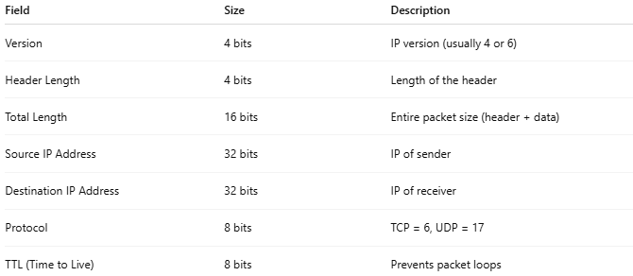
Field | Size | Description
Version | 4 bits | IP version (usually 4 or 6)
Header Length | 4 bits | Length of the header
Total Length | 16 bits | Entire packet size (header + data)
Source IP Address | 32 bits | IP of sender
Destination IP Address | 32 bits | IP of receiver
Protocol | 8 bits | TCP = 6, UDP = 17
TTL (Time to Live) | 8 bits | Prevents packet loops

🔹 3. TCP Header (Layer 4 - Transport)
# Source: Chatgpt (GPT‑5 Mini) at [12/14/2025]
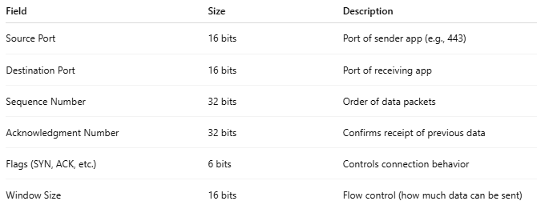
Field | Size | Description
Source Port | 16 bits | Port of sender app (e.g., 443)
Destination Port | 16 bits | Port of receiving app
Sequence Number | 32 bits | Order of data packets
Acknowledgment Number | 32 bits | Confirms receipt of previous data
Flags (SYN, ACK, etc.) | 6 bits | Controls connection behavior
Window Size | 16 bits | Flow control (how much data can be sent)

🔹 4. Payload (Data) (Layer 5–7 - Application)
# Source: Chatgpt (GPT‑5 Mini) at [12/14/2025]
- This is the actual message being sent — such as:
  - An HTTP request
  - A file segment
  - A chat message

🔹 5. FCS (Frame Check Sequence) (Ethernet trailer)
# Source: Chatgpt (GPT‑5 Mini) at [12/14/2025]
Field | Description
4 bytes | Used for error checking at the Data Link Layer (CRC check)

📦 Visual Summary
# Source: Chatgpt (GPT‑5 Mini) at [12/14/2025]
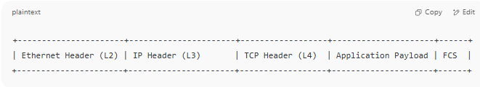
+----------------------+----------------------+------------------+---------------------+------+
| Ethernet Header (L2) | IP Header (L3) | TCP Header (L4) | Application Payload | FCS |
+----------------------+----------------------+------------------+---------------------+------+

🔍 Real Example (Simplified)
# Source: Chatgpt (GPT‑5 Mini) at [12/14/2025]
Sending: GET /index.html to www.example.com
- Source MAC: 00:1A:2B:3C:4D:5E
- Dest MAC: 00:11:22:33:44:55
- Source IP: 192.168.1.100
- Dest IP: 93.184.216.34
- Source Port: 51723
- Dest Port: 80 (HTTP)
- Payload: GET /index.html HTTP/1.1\r\nHost: www.example.com\r\n\r\n
Great! Let's break it down with a real-world example of a network packet showing the Header, Payload, and Trailer components using a simple analogy and then a technical example.

Conceptual Analogy: Mail Envelope
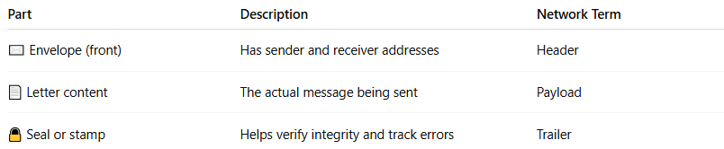
Part | Description | Network Term
✉️ Envelope (front) | Has sender and receiver addresses | Header
📄 Letter content | The actual message being sent | Payload
🔒 Seal or stamp | Helps verify integrity and track errors | Trailer

Network Packet Example (Ethernet + IP + TCP)
# Source: Chatgpt (GPT‑5 Mini) at [12/14/2025]
Imagine you're sending a message like:
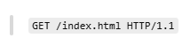
GET /index.html HTTP/1.1
Through the network, it would be encapsulated like this:

🧾 A. Header
# Source: Chatgpt (GPT‑5 Mini) at [12/14/2025]
Contains routing and protocol information
Example:
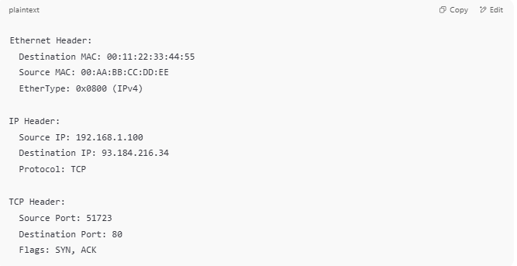
Ethernet Header:
Destination MAC: 00:11:22:33:44:55
Source MAC: 00:AA:BB:CC:DD:EE
EtherType: 0x0800 (IPv4)

IP Header:
Source IP: 192.168.1.100
Destination IP: 93.184.216.34
Protocol: TCP

TCP Header:
Source Port: 51723
Destination Port: 80
Flags: SYN, ACK

📦 B. Payload (Data)
# Source: Chatgpt (GPT‑5 Mini) at [12/14/2025]
This is the actual content being delivered.
Example:
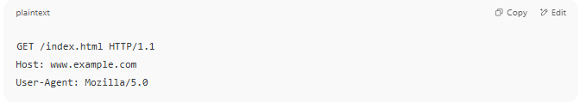
GET /index.html HTTP/1.1
Host: www.example.com
User-Agent: Mozilla/5.0

🔚 C. Trailer
# Source: Chatgpt (GPT‑5 Mini) at [12/14/2025]
Added at the end of the packet, often for error checking.
Example (Ethernet Trailer):
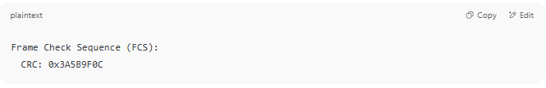
Frame Check Sequence (FCS):
CRC: 0x3A5B9F0C

🧠 Final Packet Flow:
# Source: Chatgpt (GPT‑5 Mini) at [12/14/2025]
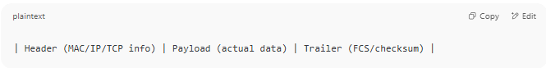
| Header (MAC/IP/TCP info) | Payload (actual data) | Trailer (FCS/checksum) |

📌 Summary Table:
# Source: Chatgpt (GPT‑5 Mini) at [12/14/2025]
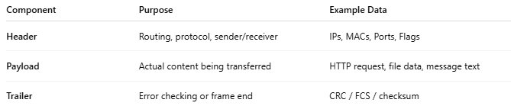
Component | Purpose | Example Data
Header | Routing, protocol, sender/receiver | IPs, MACs, Ports, Flags
Payload | Actual content being transferred | HTTP request, file data, message text
Trailer | Error checking or frame end | CRC / FCS / checksum

📡 How Packets Work
# Source: Chatgpt (GPT‑5 Mini) at [12/14/2025]
- Data is split into packets at the sender.
- Each packet is routed independently across the network.
- At the receiver, packets are reassembled in the correct order.
- If any packet is lost or corrupted, it can be retransmitted.

🧾 Key Features
# Source: Chatgpt (GPT‑5 Mini) at [12/14/2025]
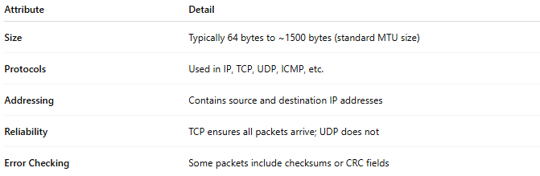
Attribute | Detail
Size | Typically 64 bytes to ~1500 bytes (standard MTU size)
Protocols | Used in IP, TCP, UDP, ICMP, etc.
Addressing | Contains source and destination IP addresses
Reliability | TCP ensures all packets arrive; UDP does not
Error Checking | Some packets include checksums or CRC fields

✅ Advantages of Packet-Switched Networks
# Source: Chatgpt (GPT‑5 Mini) at [12/14/2025]
- 💡 Efficient use of bandwidth
- 🛠 Easy to reroute around congestion
- 🔄 Retransmission of only lost packets
- 🌐 Works well over the internet (IP-based)

❌ Possible Issues
# Source: Chatgpt (GPT‑5 Mini) at [12/14/2025]
- ❌ Packet loss due to congestion or signal issues
- 🔁 Out-of-order packets need reordering
- 🐢 Latency/jitter in real-time streams

📌 Summary
# Source: Chatgpt (GPT‑5 Mini) at [12/14/2025]
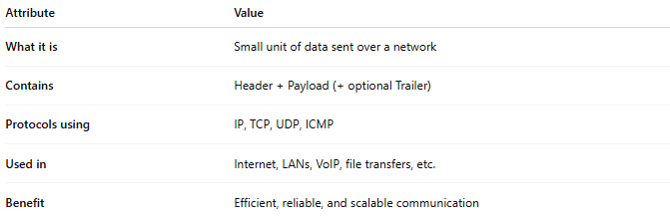

Attribute | Value
What it is | Small unit of data sent over a network
Contains | Header + Payload (+ optional Trailer)
Protocols using | IP, TCP, UDP, ICMP
Used in | Internet, LANs, VoIP, file transfers, etc.
Benefit | Efficient, reliable, and scalable communication

